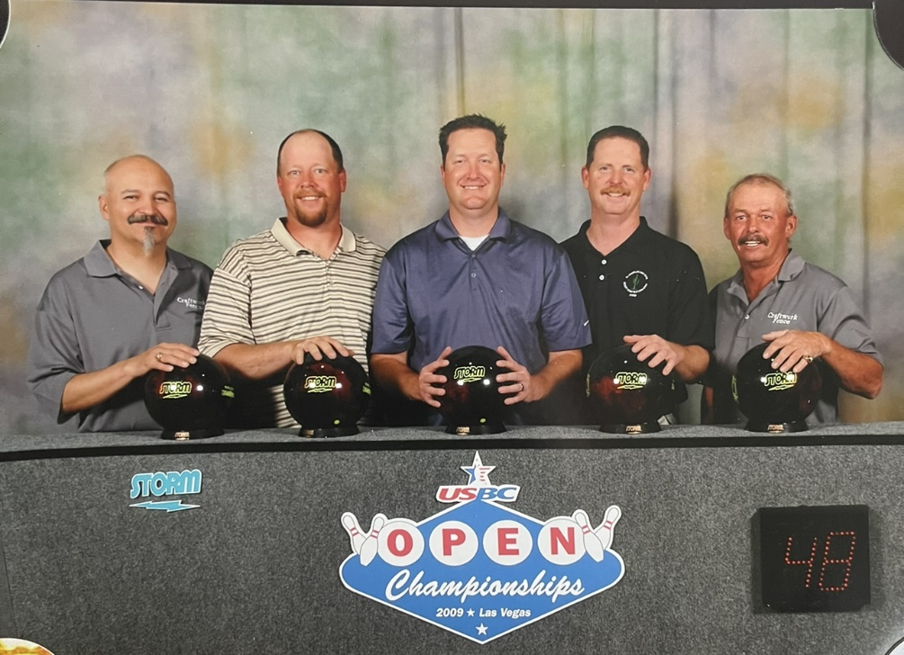

**8/4/56-10/21/23**



Please email Torri at [torri2526@gmail.com](mailto:torri2526@gmail.com) for additional information and team registration with the subject line Golf Tournament. – Thank you!

Date: March 23, 2024

Check in: 7:00 AM Tee off: 8:00 AM

Cost: Register teams of 4 - $75/golfer

**Raffle prizes and 50/50 raffle**

**\*\*1st Place Golfer** $500\*\***

Proceeds will be divided with the family for medical debt as well as the Cerbat Cliffs Youth Golf Program.

Following the tournament, we will hold a celebration of his life across the street the Elks Lodge. The start time is tentative completion of golfers. We have the Elks until 6pm.

Food and drinks will be served.

F

Join us in celebrating the life of Gene Suggs by doing one of his favorite pass times. Gene spent 30 years golfing and bowling in Kingman along with working along side many. He made so many friends throughout the years and we would love to celebrate him with you all. – The Suggs Family

**Gene-O Memorial**

**Golf Tournament**